

Sharon Lam, Stephen Richard, Gioachino Roberti

Minerva Intelligence | 301 – 850 West Hastings St, Vancouver, BC, V6C 1E1

25 March 2019

A Federated OpenDRR Platform to Support Disaster Resilience Planning in Canada

High Level Requirements

Table of Contents

List of Figures III

List of Tables III

Executive Summary 1

1.0 General Information 2

1.1 Project Team 2

1.2 Contributors 2

1.3 Reviewers 2

2.0 Introduction 3

2.1 Background 3

2.2 Business Case 3

2.3 Project Scope 5

2.4 Document Outline 5

3.0 Stakeholder Analysis 6

3.1 Risk Analyst 7

3.2 Emergency Manager 7

3.3 Land-Use Planner 7

3.4 Financial Risk Manager 7

3.5 Individual Home or Business Owner 7

4.0 Ontological Approach to Disaster Risk Reduction 7

4.1 Vocabularies 8

4.1.1 UNISDR - Sendai Framework for Disaster Risk Reduction 9

4.1.2 INSPIRE - Infrastructure for Spatial Information in the European Community 9

4.1.3 GEM – Global Earthquake Model 12

4.1.4 MOVER - Multi-Hazard Open Vulnerability Platform for Evaluating Risk 12

4.2 Strategy for Ontology & Taxonomy Development 12

5.0 Influences for OpenDRR Platform Architecture 16

5.1 Spatial Data Infrastructure 16

5.1.1 Federal Geospatial Platform – Government of Canada 16

5.2 Risk Management Platforms 17

5.2.1 OpenQuake – Global Earthquake Model 17

5.2.2 European Risk Management Platforms 18

5.2.3 Risk Data Hub – European Commission 18

5.2.4 British Columbia Earthquake Risk Portal 18

5.2.5 RiskScape – New Zealand 19

6.0 OpenDRR Target State 20

6.1 System Requirements 22

6.2 Functional Requirements 22

6.2.1 Use Case A: Knowledge Capture By Domain Expert 23

6.2.2 Use Case B: System-To-System Interoperability 23

6.2.3 Use Case C: Aggregation Area Analysis & Reporting 24

6.2.4 Use Case D: Asset-level Analysis & Reporting 25

6.3 Non-Functional Requirements 25

7.0 Implementation Strategy 26

7.1 Interoperability Strategy 26

7.2 Incremental Implementation Strategy 27

8.0 Conclusions 28

Appendix A – User Profiles A1

Appendix B - Vocabularies and Ontologies B1

B1 UNISDR - Sendai Framework for Disaster Risk Reduction B1

B2 INSPIRE - Infrastructure for Spatial Information in the European Community B5

B3 GEM – Global Earthquake Model B6

B4 MOVER - Multi-Hazard Open Vulnerability Platform for Evaluating Risk B8

Appendix C – Feature Comparison Matrix C1

References i

Glossary iii

# List of Figures

Figure 1 ‘The Global Risk Landscape 2019’ Impact- Likelihood of risk perception graph. 4

Figure 2 The components for assessing risk. 8

Figure 3 INSPIRE Natural Risk Zone UML diagram 10

Figure 4 The INSPIRE Building UML diagram 11

Figure 5 From OpenQuake to OpenDRR and end users 13

Figure 6 Steps for an ontology creation 14

Figure 7 OpenDRR risk metrics table summary 15

Figure 8 OpenDRR taxonomy table summary 15

Figure 9 OpenDRR in the context of the Federal Geospatial Platform (FGP) 17

Figure 10 British Columbia Earthquake Risk Portal - Example of Earthquake Risk Reporting Tool 19

Figure 11 Generic Framework of RiskScape for risk assessment tools in OpenDRR 20

Figure 12 OpenDRR Integration and Delivery of Information within Federal Geospatial Platform. 21

Figure 13 User-Centric Approach to Open, Decision Support Systems 22

Figure 14. The importance of definition of standards. B1

Figure 15 Metrics for Risk assessment. B4

Figure 16 Natural Risk Zone Application schema B5

Figure 17 Radial graph view of Natural Hazard Category Value code list. B6

Figure 18 Factors of social vulnerability B7

Figure 19 extract of MOVER vulnerability schema B10

# List of Tables

Table 1 OpenDRR System Requirements 22

Table 2 OpenDRR Functional Requirements - Use Case A: Knowledge Capture By Domain Expert 23

Table 3 OpenDRR Functional Requirements - Use Case B: System-to-System Interoperability 24

Table 4 OpenDRR Functional Requirements - Use Case C: Aggregation Area Analysis & Reporting 24

Table 5 OpenDRR Functional Requirements - Use Case D: Asset-Level Analysis & Reporting 25

Table 6 OpenDRR Non-Functional Requirements 25

# Executive Summary

Successful disaster risk reduction requires an integrated approach that facilitates the interpretation and delivery of disaster risk assessments across different verticals.

The Open Disaster Risk Reduction (OpenDRR) is a broad initiative to provide a linked data solution that addresses the needs of various stakeholders in the disaster risk assessment process on a common platform. The goal is to design and implement an open source platform that can be adopted by the global community to support disaster risk management, starting with earthquake risk reduction. The platform will be key to informing policy choices, empowering the decision-making process and encouraging risk mitigation practices among individuals and business owners.

The objective of this document is to provide high-level recommendations for an OpenDRR solution through a user-centric and standards-based approach as part of the national Disaster Risk Reduction (DRR) Pathways project to provide incentives for mitigation & adaptation investments in Canada.

Five stakeholder user groups are the actors in four primary use cases providing guidance for the recommendations here. Through a review of profiles for each user group, functional requirements have been derived to describe the target state of the OpenDRR platform. A survey of existing disaster risk management platforms reveals the need for users to perform risk analysis using standardized terminology. The proposed OpenDRR target state incorporates use of ontologies and taxonomies in risk communication to efficiently interpret and communicate the outputs of risk analysis

Finally, an incremental implementation strategy is proposed to guide the development of an OpenDRR solution. The successful implementation of OpenDRR will set a leading example for the Government of Canada in supporting disaster resilience planning in North America and Open Government initiatives.

# 1.0 General Information

## 1.1 Project Team

|  |  |  |  |
| --- | --- | --- | --- |
| Name | Title | Organization | Contact |
| Gioachino Roberti | Section Head, Geohazards | Minerva Intelligence | [groberti@minervaintelligence.com](mailto:groberti@minervaintelligence.com) |
| Sharon Lam | GIS Analyst | Minerva Intelligence | [slam@minervaintelligence.com](mailto:slam@minervaintelligence.com) |
| Stephen Richard | Chief Semantics Officer | Minerva Intelligence | [srichard@minervaintelligence.com](mailto:srichard@minervaintelligence.com) |

## 1.2 Contributors

|  |  |  |  |
| --- | --- | --- | --- |
| Name | Title | Organization | Contact |
| Murray Journeay | Research Scientist | Geological Survey of Canada, Natural Resources Canada | [murray.journeay@canada.ca](mailto:murray.journeay@canada.ca) |
| Sahar Safaie | Founder and Principal Consultant | Sage On Earth Consulting Ltd. | [sahar.safaie@sageonearth.ca](mailto:sahar.safaie@sageonearth.ca) |

## 1.3 Reviewers

|  |  |  |  |
| --- | --- | --- | --- |
| Name | Title | Organization | Contact |
| Clinton Smyth | CEO | Minerva Intelligence | [cpsmyth@minervaintelligence.com](mailto:cpsmyth@minervaintelligence.com) |
| Jake McGregor | Section Head, Geospatial Technologies | Minerva Intelligence | [jmgregor@mintervaintelligence.com](mailto:jmgregor@mintervaintelligence.com) |

# 2.0 Introduction

## 2.1 Background

The Open Disaster Risk Reduction (OpenDRR) platform is an initiative to provide tools for disaster impact reduction through incentives for mitigation & adaptive investments as part of the Canadian national Disaster Risk Reduction (DRR) Pathways project.

The DRR-Pathways project builds on demonstrated capabilities for integrated risk modelling, and the strengths of trusted regional partnerships. These partnerships have been established through a progression of studies, demonstration projects, and strategic planning initiatives carried out at municipal, regional and provincial scales in western and central Canada.

Insights from these risk assessment projects have established a solid foundation of knowledge, methodology and expertise on which to develop a collaborative platform for evaluating the efficacy of disaster risk reduction investments at multiple scales in terms of both economic utility (willingness to pay), and policy trade-offs required to ensure longer-term disaster resilience (willingness to accept).

The OpenDRR platform aims to provide tools to investigate, assess, and mitigate natural disasters for policy makers, risk analysts, private and public institutions, and citizens to facilitate decision-making prior to and during crisis.

## 2.2 Business Case

The international community is becoming more aware of the risk related to natural disasters (Figure 1), and individuals, businesses and government leaders are increasingly receptive to the principles of systemic risk and disaster resilience planning.[1] However, they are unlikely to take actions in advance of a disaster without a clearly defined value proposition.

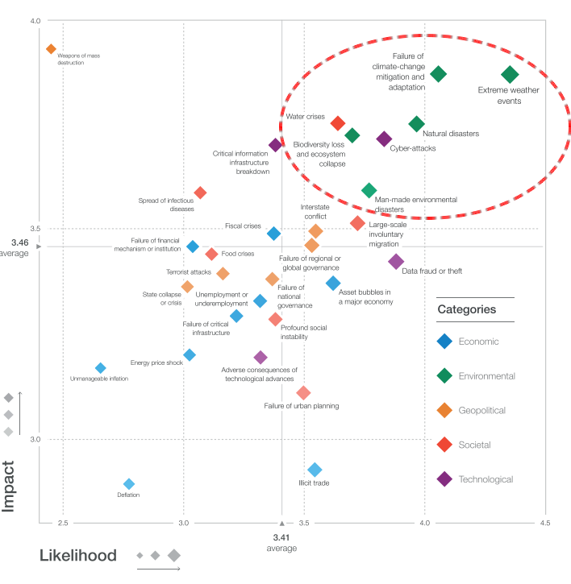

Figure 1 ‘The Global Risk Landscape 2019’ Impact- Likelihood of risk perception graph. People are becoming more aware of the environmental changes and the related risks. Red dashed circle highlights the environmental risks. (Modified form World Economic Forum 2019)

The conventional approach is to motivate risk reduction decisions using quantitative risk assessment methods to analyze expected impacts and consequences, and to measure the relative costs and benefits of proactively investing in mitigation and/or adaptation measures. The expectation is that a positive rate of return on financial investments will provide the necessary incentive for individuals and organizations to take actions that will increase the disaster resilience of their homes, businesses and communities.

The problem with this approach is that most quantitative assessment frameworks do not measure dynamic conditions of risk within the broader interconnected network of buildings, critical infrastructure, socioeconomic systems and environmental assets that define a community or region. They are also limited in their capacity to make evident either viable pathways for risk reduction (strategies), or the rationale for proactive investments in mitigation and adaptation measures across different stakeholder groups (incentives).

Individuals, businesses and institutions responsible for making disaster risk reduction decisions (DRR) are not always directly engaged in the risk assessment process. As a result, the outputs of conventional science-based risk assessments (probable impacts and consequences) are often perceived as a liability and constraint to growth and development even if it can be demonstrated that proactive investments in mitigation and adaptation measures yield a positive rate of return and make good sense from a business perspective.

For these reasons, there is an urgent need to develop a more integrated approach to the risk assessment process – one that situates the analysis of systemic risk in the broader context of strategic planning, and that provides the necessary base of evidence to inform the evaluation of policy choices and to empower the decision-making process.

## 2.3 Project Scope

The objective of this document is to define scope for the OpenDRR platform and provide recommendations on system architecture based on the user cases and data/systems needs as part of the DRR-Pathways project in Canada.

The Platform will be part of a federated spatial data infrastructure that will support an open access web-mapping application to explore hazard and risk scenarios generated with the OpenQuake platform or other Global Earthquake Model tools. The web-based platform will be an effective tool for investment decisions made by individuals, businesses, communities and institutions in support of Canada’s National Disaster Mitigation Strategy.

## 2.4 Document Outline

This OpenDRR High Level Requirements document is structured as follows:

* *Section 1: General Information* – This section provides information and contact details for the project team and other contributors.
* *Section 2: Introduction* – This section provides the background information, business case and scope for this project.
* *Section 3: Stakeholder Analysis* - This section identifies five user groups and their role in disaster risk reduction to guide the development of the OpenDRR platform.
* *Section 4: Ontological Approach to Disaster Risk Reduction* – This section explores the topic of standards through taxonomies and ontologies. Existing risk vocabularies are discussed in the context of adaptation and specific implementations to serve the OpenDRR platform.
* *Section 5: Influences for OpenDRR Platform Architecture* – This section reviews existing disaster risk platforms to define the best possible structure of the OpenDRR platform.
* *Section 6: OpenDRR Target State* – This section describes the target state for the OpenDRR platform in terms of system and functionality requirements.
* *Section 7: Implementation Strategy* – This section proposes a strategy for interoperability and implementation for OpenDRR.
* *Section 8: Conclusions* – This section summarizes the need for an OpenDRR platform based on the topics reviewed in this document.
* *Appendix A: User Profiles* – User stories for three of the five stakeholders identified in Section 3
* *Appendix B: Vocabularies and Ontologies* – A collection of existing vocabularies relevant to the development of OpenDRR.
* *Appendix C: Feature Comparison Matrix* – A tabular comparison of frameworks and capabilities of spatial data infrastructure and web mapping platform implementations under review.

# 3.0 Stakeholder Analysis

In order to develop a successful program for disaster risk reduction, there needs to be seamless interaction between researchers, policy makers, planners, and the public based on a common understanding. The OpenDRR initiative aims to address this gap by prioritizing the end-user experience in guiding product development. Five scenarios for a federated OpenDRR platform were identified from which five user profiles were inferred.

The scenarios are as follows:

* Connect to the OpenQuake platform and Federal Geospatial Platform (FGP) to enable data sharing between Canadian node and other nodes in the global earthquake hazard network
* Connect to provincial platforms (GeoBC, EMBC, Data Warehouse BC) to support provincial government and municipal emergency management operations
* Support federal government evaluation of financial security in case of catastrophic event and support the financial sector with evaluation of potential risks as input for design of insurance policies
* Connect to municipal platforms for land use planners to use hazard and risk information in policy design
* Inform citizens and small businesses of risk to identify cost-effective risk mitigation activities

The Users described in the following section are the Risk Analyst, the Emergency Manager, the Land-use planner, the Financial Risk manager and the Individual Home or Business Owner.

## 3.1 Risk Analyst

Risk analysts are domain experts responsible for acquisition and analysis of hazard data to develop risk assessment, and update assessments as new data become available. The primary role of the OpenDRR system for this stakeholder is as a vehicle for disseminating results in a manner that is most useful to other stakeholders.

## 3.2 Emergency Manager

Emergency managers are responsible of developing strategic and operation plans to protect people and assets in case of disasters. They utilize software tools to identify areas of concern for different hazard scenarios and elaborate emergency response plans.

## 3.3 Land-Use Planner

Land-use planners develop policy strategies to manage the allocation and utilization of land, balancing competing demands for economic vitality, social justice, quality of life, and environmental integrity. They manage planning processes to identify and develop policy recommendations that are informed by relevant scientific and technical knowledge.

Land-use planners have the responsibility of guiding sustainable land development. They utilize software tools to assess hazard areas and make determinations whether an area is safe for the use intended.

## 3.4 Financial Risk Manager

Insurance risk managers develop models used to set insurance rates based on assessment of aggregate risk. They will rely on OpenDRR to provide site specific and regional hazard assessment, and risk models for comparison with their own models.

## 3.5 Individual Home or Business Owner

Individual property owners are responsible for the maintenance and safety of their assets. They will query the OpenDRR system to obtain reliable assessments of risks to their property.

# 4.0 Ontological Approach to Disaster Risk Reduction

Disaster Risk Reduction is a complex multi-variate analysis that requires detailed knowledge of both the hazardous phenomena (earthquake, floods, wildfires, etc.) and the human components of risk (Figure 2). In order to investigate the multiple data sources required for risk calculation and to share the risk analysis, both input and output data must be expressed in consistent, standardized terminology and format to enable analysis and increase efficiency. This data standardization is challenging, but necessary and highly rewarding (Abbas & Ojo, 2013; Guidoin, Marczak, Pane, & McKinney, 2014; Harvey et al., 2014; Schade & Lutz, 2010). Some terms have multiple interpretations across language, culture, and applications leading to confusion when used (Kelman, 2018). However, once the issue of inconsistent terminology is overcome, detailed hazard and risk taxonomies can be utilized to allow integrated data investigation (Xu & Zlatanova, 2007). Ontologies are valuable tools when it comes to hazard and risk analysis where a common understanding needs to be established for interoperability. Ontologies provide a basis for integration of relevant information across a distributed network of systems and facilitates hidden and implicit knowledge discovery.

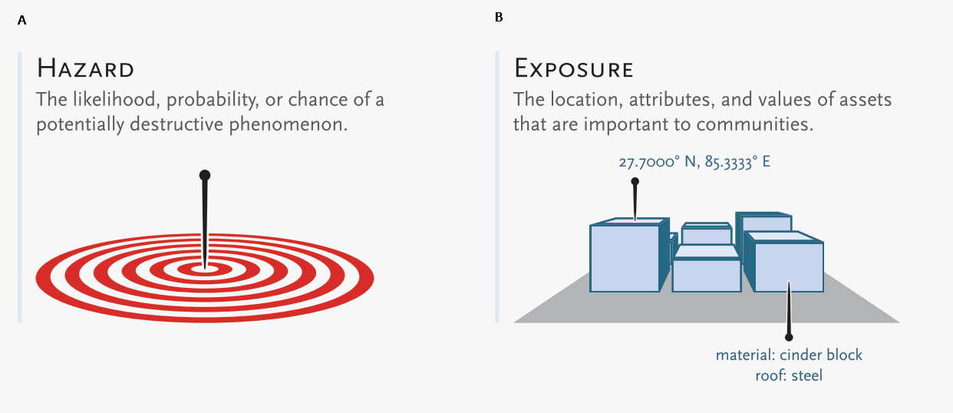

Figure 2 The component for assessing risk. A) Hazard- the natural system component of risk. B) Exposure – the human component of risk. (Modified from World Bank 2014)

Standardization of data and vocabularies has fostered applications at national (for example: Vilches-Blázquez et al. 2010) and international levels (for example: Arctic SDI 2015). However, according to a review of several risk web platforms by the European Commission, the presentation of disaster risk information varies between platforms and hence is not easily interpreted for integrated analyses (Antofie, Doherty, & Marin-Ferrer, 2018). This section explores some current implementations of standardized vocabularies to be considered for OpenDRR.

## 4.1 Vocabularies

Initiatives in data standardization and vocabularies definition include the Commission for the Management and Application of Geoscience Information (CGI) (Sen & Duffy, 2005) and Infrastructure for Spatial Information in the European Community (INSPIRE) (Mijić & Bartha, 2018). Regarding specific vocabularies for disaster risk reduction, the Sendai Framework (UNISDR, 2015) represents a global reference that other initiatives, including INSPIRE, have used as a foundation.

### 4.1.1 UNISDR - Sendai Framework for Disaster Risk Reduction

The United Nations Office for Disaster Risk Reduction (UNISDR) developed the Sendai Framework (UNISDR, 2015) in order to provide states and stakeholders guidelines for disaster risk reduction. UNISDR recognized the need for common terminology to foster disaster risk reduction efforts among local, national, and international parties, and has developed the Sendai Framework hazard and risk vocabularies (UN, 2016) translated in Arabic, Chinese, English, French, Russian and Spanish. Sendai Framework vocabularies have been adopted and expanded by various disaster risk reduction initiatives including GEM and INSPIRE (see following sections). The Sendai Framework global targets are summarized in Appendix B1.

### 4.1.2 INSPIRE - Infrastructure for Spatial Information in the European Community

The INSPIRE directive is a policy in the European Union aimed at standardizing the dissemination of spatial data. Spatial data in this context refers to any information that is tied to a location. This data spans a broad spectrum of disciplines and includes many different types, including monitoring station records, vector-based maps like geological maps, land cover maps and transportation maps or pixel-based raster maps for imagery or coverage data. All providers of spatial data in the public realm must adhere to INSPIRE from the national to the Municipal level. The vocabulary related to risk is described in the Natural Risk Zone (Figure 3) theme of Annex 3 and draws from the Sendai Framework guideline (EU expert working group on disaster damage and loss data, 2015; INSPIRE Infrastructure for Spatial Information in Europe, 2013).

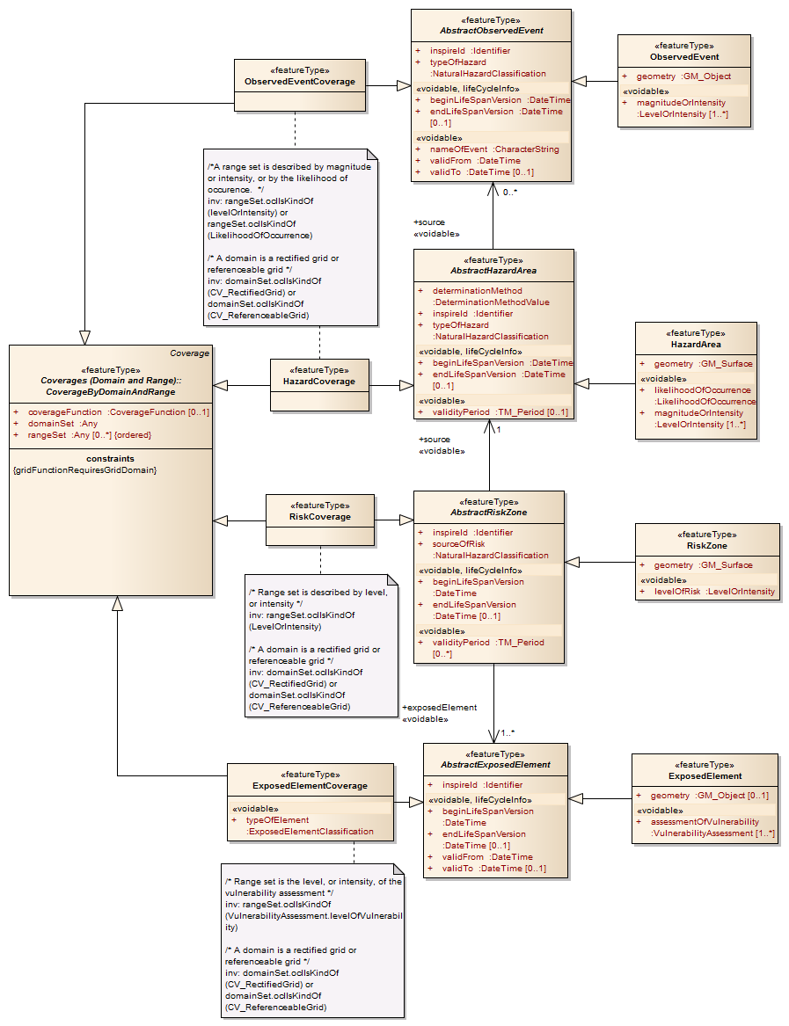

Figure 3 INSPIRE Natural Risk Zone UML diagram https://inspire.ec.europa.eu/data-model/approved/r4618-ir/html/index.htm?goto=2:3:12:1:8552

The Natural Risk Zone data theme includes vocabularies to assess the hazard and the human component of risk. The terminology to describe detailed building characteristics resides in the INSPIRE building theme of Annex 3. This building taxonomy is built on top of the CityGML initiative (Figure 4) (INSPIRE Thematic Working Group Buildings, 2013). The CityGML taxonomy has as a primary objective the storing and exchanging of virtual 3D city models[2], focused on building geometry and location, not on the engineering aspects of building construction.

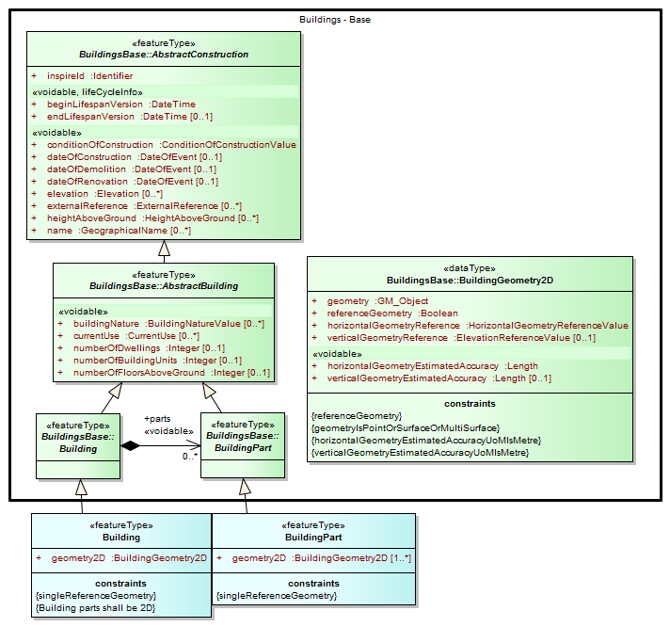

Figure 4 The INSPIRE Building UML diagram (<https://inspire.ec.europa.eu/data-model/approved/r4618-ir/html/index.htm?goto=2:3:2:2:7911>)

### 4.1.3 GEM – Global Earthquake Model

The Global Earthquake Model (GEM) is a private-public foundation with the goal of supporting disaster risk reduction and decision-making processes at the local, national and global scale. Recognizing the value of standardized data, GEM has developed various detailed taxonomies, including extensions of Sendai indicators for the specific scope of earthquake disaster risk calculation. Social and analytical indicators have been defined, including a detailed Multi-Hazard Exposure building taxonomy (Silva, Yepes-Estrada, Dabbeek, & Martins, 2017).[3] The GEM building classification has the primary objective to be used in earthquake science, and was developed from other taxonomies including the EERI World Housing Encyclopedia[4], PAGER[5], and HAZUS[6]. A graphical tool for constructing GEM building classification strings is also available.[7] Appendix B2 further explores GEM’s indicators.

### 4.1.4 MOVER - Multi-Hazard Open Vulnerability Platform for Evaluating Risk

The UK Department for International Development and the Global Facility for Disaster Reduction and Recovery[8] promoted the open multi-hazard vulnerability database - MOVER (Multi-Hazard Open Vulnerability Platform for Evaluating Risk) project (Epicentre 2018)[9] for developing countries. Terms used by MOVER are based on definitions adopted by the Global Earthquake Model (GEM). The MOVER project has developed modules for describing Vulnerability, Fragility and Damage to Loss Functions, Physical Indicators, Social Indicators, and Physical, Social and Hybrid Indices. Each module includes vocabularies with dictionary tables that cross reference terms in other modules. Appendix B4 shows an extract of MOVER’s vulnerability schema.

## 4.2 Strategy for Ontology & Taxonomy Development

The integration of geo-information to help decision-making prior to and during an emergency is fundamental for the OpenDRR platform. The enabler for this integration is an ontology for disaster risk reduction in Canada that harmonizes existing vocabularies for hazard and risk (SENDAI, INSPIRE, GEM) and includes new concepts where needed to support semantic interoperability and natural language reasoning (Figure 5).

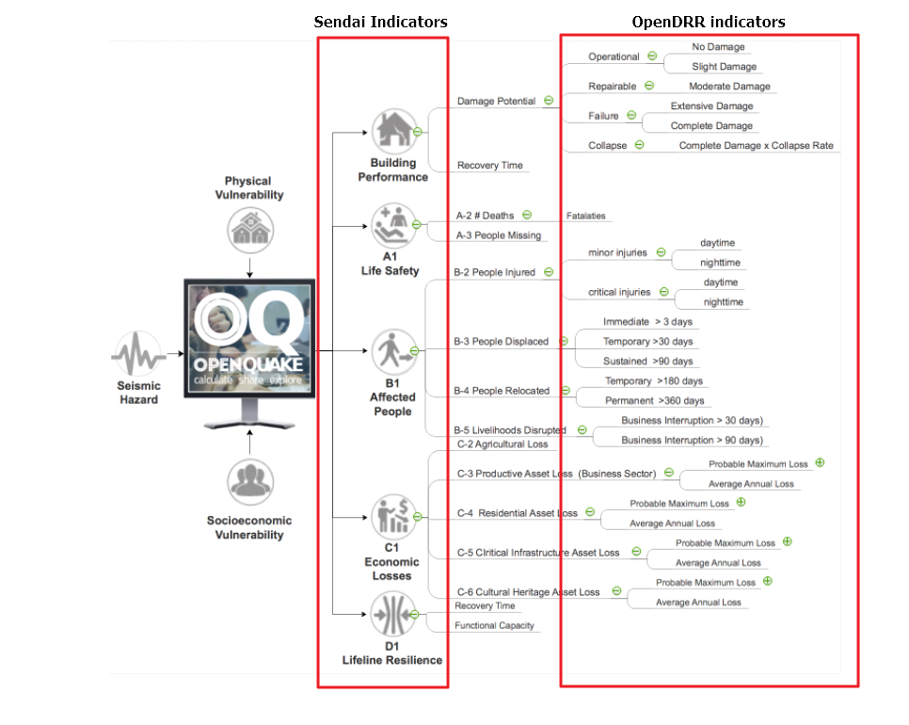

Figure 5 From OpenQuake to OpenDRR and end users (M. Journeay, personal communication)

Detailed vocabulary assessment is needed to evaluate aligning GEM terminology to INSPIRE standards, especially regarding the building taxonomy. The GEM building taxonomy has been tailored to the earthquake study needs while the INSPIRE-CityGML is not. For example, GEM vocabulary includes categories for building materials e.g. ‘metal (excluding steel)’ for roofs while CityGML has only a ‘metal’ generic category[10]. In order to have consistency between systems, a clear distinction needs to be made between building performance indicators that are based on building use and building construction indicators, based on building structure. Construction details are important input for estimations of building damage in flood or earthquake scenarios, hence the GEM taxonomy seems more applicable to the OpenDRR platform scope.

The OpenDRR ontology should ultimately be structured to satisfy the identified use cases (6.0 OpenDRR Target State). Development of an ontology for data integration will follow standard workflow processes (Figure 6).

Figure 6 Steps for an ontology creation. (Noy & McGuinness, 2001)

1. Determine scope. Review use cases and stakeholder analysis (Section 3).
2. Enumerate terms. Identify outputs from OpenQuake and the link to the OpenDRR indicator (Figure 7):

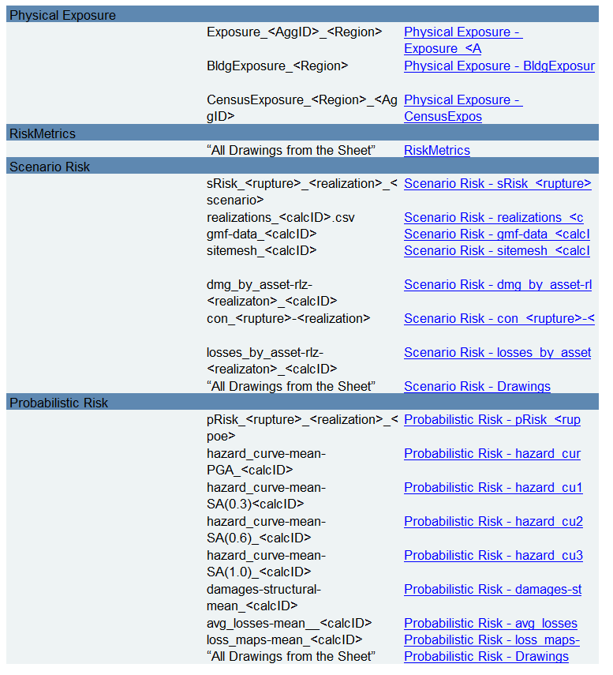

Figure 7 OpenDRR risk metrics table summary (M. Journeay, personal communication)

1. Identify existing vocabularies that are in use and could be harmonized (Figure 8). Terminology is needed to specify categorical data values, identify algorithms for calculating risk metrics, and to communicate risk assessment conclusions to both technical users and the general public.

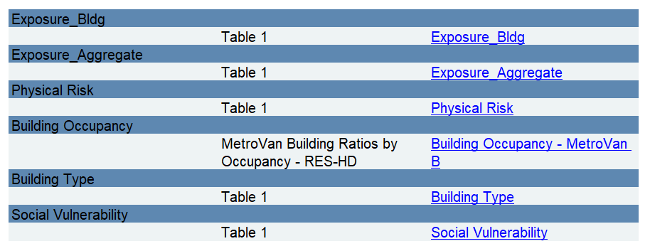

Figure 8 OpenDRR taxonomy table summary (M. Journeay, personal communication)

1. Define relations between concepts. Implement indicators vocabularies
2. Define constraints for logical validation
3. Define instances for actual occurrence descriptions.

# 5.0 Influences for OpenDRR Platform Architecture

The initial release of the OpenDRR Platform will provide departmental capabilities for Natural Resources Canada (NRCan) within the Federal Geospatial Platform (FGP) to support the OpenQuake initiative in Canada. The goal is to design and implement an open source platform that can be adopted by the global community to support disaster risk management, starting with earthquake risk reduction. Hence, the architecture of FGP and other relevant spatial data infrastructures needs to be considered to determine industry best practices. This section reviews a collection of exemplary risk management platforms that share the same vision as the OpenDRR platform. Additional comparisons are illustrated in a feature comparison matrix in Appendix C.

## 5.1 Spatial Data Infrastructure

### 5.1.1 Federal Geospatial Platform – Government of Canada

The Federal Geospatial Platform is a collaborative online environment that enables the Government of Canada to efficiently manage and share authoritative geospatial data, services and applications. Since the OpenDRR platform will be a subsystem within a federated architecture (Figure 9), the OpenDRR platform should complement the objectives of the FGP. The objectives are as follows (Natural Resources Canada, 2015):

* Better support for decision-making
* Stimulate economic development and technological innovation
* Increase efficiency and effectiveness in information management and acquisition
* Support open government initiatives
* Standardize information management

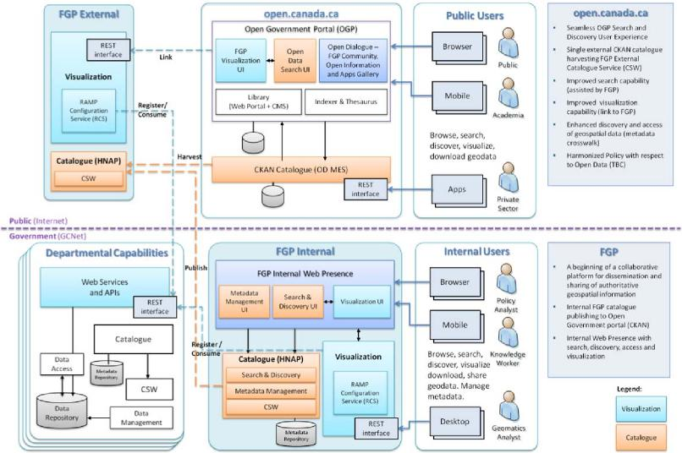

OpenDRR

Figure 9 OpenDRR (red squares) in the context of the Federal Geospatial Platform (FGP) (Natural Resources Canada, 2015)

## 5.2 Risk Management Platforms

In order to successfully communicate recommendations for risk reduction to a wide audience, risk assessments and accompanying datasets need to be accessible and customizable. Based on the current inventory of available risk management platforms reviewed by the European Commission, a web-based platform is most desirable (Antofie et al., 2018). A web-based, service-oriented platform has the potential to provide tools for searching data repositories, data visualization, and analysis tools that can be tailored to the needs of various user groups.

This section reviews the capabilities of the OpenQuake Platform and several other risk management web platforms as a basis to identify the shortcomings that the OpenDRR platform aims to resolve.

### 5.2.1 OpenQuake – Global Earthquake Model

OpenQuake (OQ) is an open-source product by the Global Earthquake Model (GEM) Foundation that provides tools for building and running seismic hazard and risk assessment models and sharing the results (Global Earthquake Model, 2017). The OpenQuake Platform is an online environment in which users can explore, manipulate and visualize datasets and models produced by the OpenQuake Engine software. The OQ Platform allows users to upload datasets, which can then be used to create web map overlays and share them with the OQ community. Online tools are available to domain experts to contribute to the inventory of active faults, physical vulnerability functions, and building classifications. However the platform lacks a connected framework that allows all users to customize the interpretation of risk indicators for their domain, from emergency planners to individuals and business owners. The OpenDRR platform should aim to provide a web mapping environment that extends the current functionality of the OQ Platform beyond domain experts to communicate risk management to the general public.

### 5.2.2 European Risk Management Platforms

Antofie et al. (2018) compiled an inventory of current risk management platforms in Europe and identified common characteristics. They found that many existing platforms provided hazard maps relating to exposure but few relate to socioeconomic and environmental aspects. There was also a greater focus on flood disaster risk management compared to other hazards and visualizations of risk for an area as a result of a hazard occurrence were simplified without providing statistical descriptions (Antofie et al., 2018).

### 5.2.3 Risk Data Hub – European Commission

The Disaster Risk Management Knowledge Centre (DRMKC) Risk Data Hub (<https://drmkc.jrc.ec.europa.eu/risk-data-hub>) is a web GIS platform that hosts various geospatial data and tools to support disaster risk management across Europe (Antofie et al., 2018). The web portal provides a collaborative environment in which users can share and edit geospatial layers and maps as well as interpret data combined from national and local governments, scientists, and other organizations. The Risk Data Hub offers a centralized catalog of data for disaster risk management, metadata management tools, and presents statistical analysis of risk assessments alongside geospatial data. The architecture of the OpenDRR platform should consider the use of technologies implemented in the Risk Data Hub to achieve a similar, collaborative web platform where users are both data providers and end users.

### 5.2.4 British Columbia Earthquake Risk Portal

The British Columbia Earthquake Risk Portal is an online mapping application for presenting earthquake risk information for British Columbia (NRCan, Emergency Services BC, GeoBC 2017). The portal is an example of a modern, user-centric application that provides a web map reporting tool for planners and emergency managers to export earthquake risk assessment results for an area of interest (Figure 10).

The OpenDRR platform will extend the functionality illustrated in the BC Earthquake Risk Portal using open source software to provide additional analysis tools such as:

* Updating risk indicators and recalculating risk assessments
* Uploading building inventories and performing risk calculations

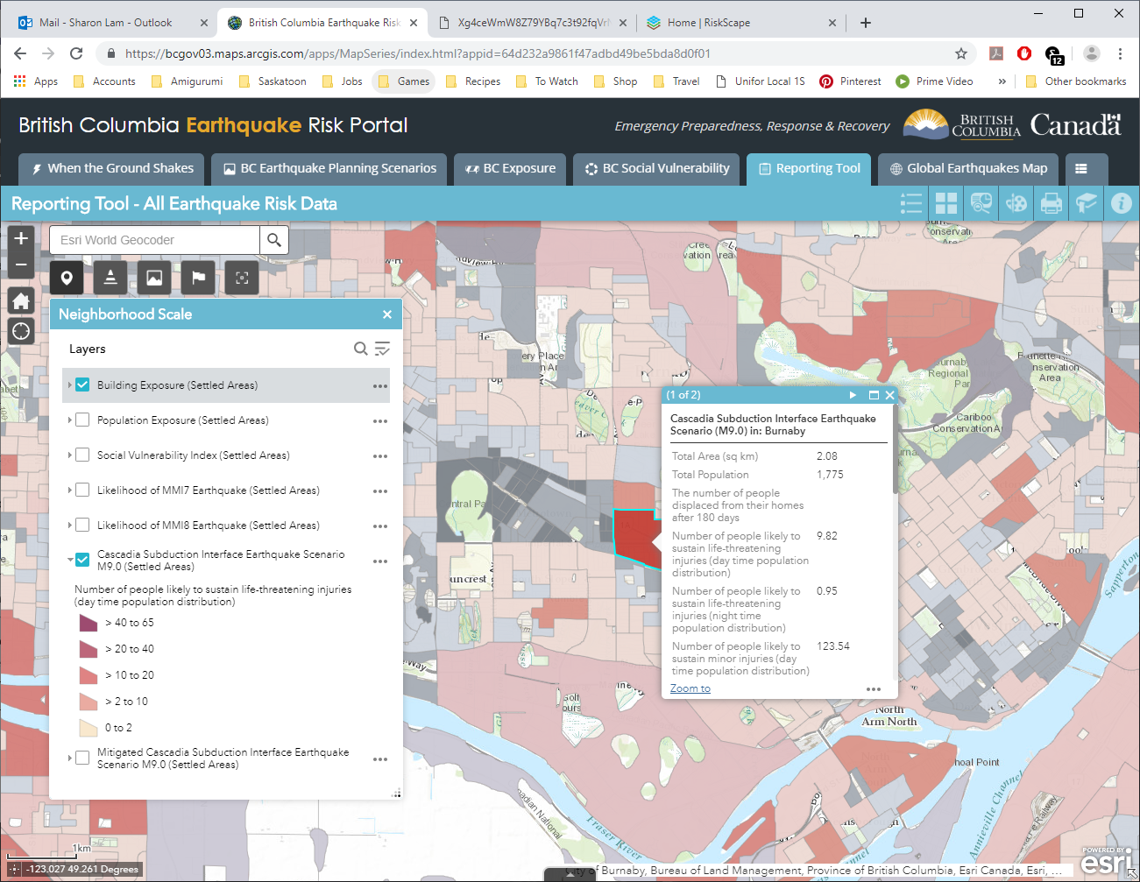

Figure 10 British Columbia Earthquake Risk Portal - Example of Earthquake Risk Reporting Tool

### 5.2.5 RiskScape – New Zealand

RiskScape is a free desktop software for natural hazard impact assessments funded by GNS Science and the National Institute of Water & Atmospheric Research (NIWA) in New Zealand. The software supports hazard model refinements by the user, the uploading of custom asset data to perform risk analysis, and viewing of results at the asset or aggregation area levels. Although the software is designed for New Zealand conditions, its modular approach for performing risk assessments makes it adaptable to different natural hazard and asset scenarios anywhere in the world (Figure 11).

The OpenDRR platform should draw on the modular design of RiskScape when designing analysis tools within the web mapping platform.

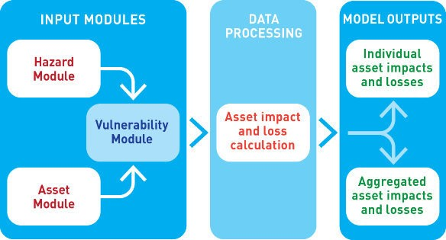

Figure 11 Generic Framework of RiskScape for risk assessment tools in OpenDRR ([https://wiki.riskscape.org.nz](https://wiki.riskscape.org.nz/))

# 6.0 OpenDRR Target State

Effective disaster risk reduction is dependent on a dynamic network of knowledge through which a wide range of users, from researchers and planners to the general public, have access to reliable and actionable information. The goal of OpenDRR is to establish a federated platform to support disaster resilience planning in Canada.

The target state for OpenDRR is to provide services for data access, search and discovery, data storage and management, and analysis tools supported by standardized vocabularies. From an architectural viewpoint, OpenDRR will need to include components that connect to the Canada’s Federal Geospatial Platform such as catalogues, data repositories, web services and OpenDRR-specific applications (Figure 12).

OpenDRR will need to provide a variety of analysis and reporting tools for decision support. A web GIS platform is recommended because it has the greatest flexibility and accessibility to support a wide range of operations and a diverse user base (Figure 13). Although the platform will initially focus on earthquake risk management, drawing on the functionality of the OpenQuake Platform, the methodological processes should be designed in a modular fashion in order to support risk management for multiple hazards.

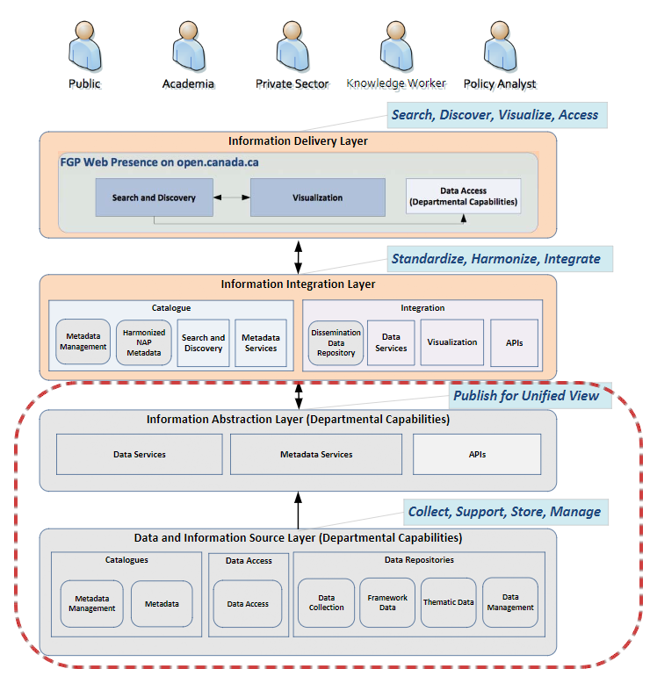

Figure 12 OpenDRR Integration and Delivery of Information within Federal Geospatial Platform. (Natural Resources Canada, 2015)

Figure 13 User-Centric Approach to Open, Decision Support Systems

The following sections describe the high-level requirements that will guide the development of OpenDRR towards the target state.

## 6.1 System Requirements

Table 1 OpenDRR System Requirements

|  |  |  |  |
| --- | --- | --- | --- |
| ID | Requirement | Description | Priority |
| 6.1.1 | Development Framework | Hybrid solution of open-source software will be used to develop the application | Mandatory |
| 6.1.2 | Interactive mapping application | The application will provide web-based GIS capabilities. This will include map navigation, search, query, print, report, etc. Additional functionality will be developed to satisfy requirements identified in the use cases. | Mandatory |
| 6.1.3 | Federal Geospatial Platform | The application will be made available to the Federal Geospatial Platform for data sharing within FGP as well as Open Canada. | Mandatory |
| 6.1.4 | Catalogue | A cataloguing and metadata management software is required. | Mandatory |
| 6.1.5 | Web Server | A web server for hosting spatial and non-spatial data is required. | Mandatory |

## 6.2 Functional Requirements

The functional requirements of the OpenDRR platform are divided across four use cases and described as task-level goals. The four use cases are as follows:

1. Knowledge capture by domain expert
2. System-To-System Interoperability
3. Aggregation Area Analysis and Reporting
4. Asset-level Analysis and Reporting

### 6.2.1 Use Case A: Knowledge Capture By Domain Expert

Domain experts analyze, develop, maintain, and update risk assessment models using the OpenQuake platform. Output from these models is currently aggregated and interpreted for end users through a variety of manual processes, with some automation using Python scripts. The role of the OpenDRR system for the domain expert is to automate the processes linking model runs to updated risk and hazard reports in map or tabular formats. Model results and interpretations need to be packaged in a format such that other components in the OpenDRR system can generate products on demand that are useful to other stakeholders—for example reports focused on individual sites or aggregations based on location, building types, ownership, with different planning horizons.

Table 2 OpenDRR Functional Requirements - Use Case A: Knowledge Capture By Domain Expert

|  |  |  |  |
| --- | --- | --- | --- |
| .ID | Actor | Task-level Goal | Priority |
| A.1 | Risk Analyst | Export results of earthquake and hazards modeling for input to OpenDRR system | Must Have |
| A.2 | OpenDRR Admin | Execute workflow to convert model results to data supporting end-user use cases | Must Have |
| A.3 | OpenDRR Admin | Backup data necessary for recovery from system failure or malicious disruption. | Should Have |
| A.4 | OpenDRR Admin | Store processed model results to support user query and reporting requirements. | Must Have |

### 6.2.2 Use Case B: System-To-System Interoperability

As a tool for generating user-focused maps and reports for risk and hazard assessment, OpenDRR system should support input via interfaces using standard web-based APIs and interchange formats, enabling data acquisition not only from models created on the OpenQuake platform, but from any modeling platform that implements these interfaces. In addition, the OpenDRR system should expose its query and reporting capabilities via web services to allow third parties to build applications that interact with the system. Service-based linkage using standard APIs, interchange formats, and vocabularies will allow near real time updating of output products when new assessment models are run or data are updated.

The OpenDRR will follow international data standards to facilitate system-to-system interoperability. Data will also be organized in formal ontologies to support semantic data interoperability and natural language reasoning

Table 3 OpenDRR Functional Requirements - Use Case B: System-to-System Interoperability

|  |  |  |  |
| --- | --- | --- | --- |
| ID | Actor | Task-level Goal | Priority |
| B.1 | All | Search and consume OpenDRR data as a service | Must Have |
| B.2 | OpenDRR Admin | Establish catalog and REST API connection protocols | Must Have |
| B.3 | Risk Analyst, Emergency Manager, Land-Use Planner, Financial Risk Manager | Publish models and reports to FGP Catalogue | Should Have |
| B.4 | Risk Analyst, Emergency Manager, Financial Risk Manager | Transfer data to FGP Data Repository | Could Have |
| B.5 | Risk Analyst | Update and maintain metadata catalogue in FGP Data Repository | Could Have |

### 6.2.3 Use Case C: Aggregation Area Analysis & Reporting

This scenario is focused on regional planning activities to assess resilience, for allocation of resources for preparedness, and to evaluate policy options for regulatory actions. Users will require reports aggregating estimated damage potential, economic impacts, and loss of life or injury over various jurisdictions. Users will rely on OpenDRR to generate authoritative reports, with presentations that are intelligible to non-expert planners and decision makers. The ability to trace interpretations back to supporting evidence is important.

Table 4 OpenDRR Functional Requirements - Use Case C: Aggregation Area Analysis & Reporting

|  |  |  |  |
| --- | --- | --- | --- |
| ID | Actor | Task-level Goal | Priority |
| C.1 | Emergency Manager, Community Planner, Financial Risk Manager | Obtain risk analysis report aggregated for an area of interest | Must Have |
| C.2 | Emergency Manager, Community Planner, Financial Risk Manager | Get explanation for risk factors in a report | Should Have |
| C.3 | Emergency Manager | Obtain report on socio-economic impact for actual or potential hazard event | Could Have |
| C.4 | Community Planner | Obtain report on socio-economic risk for land development scenarios. | Could Have |
| C.5 | Financial Risk Manager | Obtain report on economic impact and probabilities for an area of interest. | Must Have |
| C.6 | Community Planner | Obtain report on probabilities and time horizons for possible level of ground-shaking in an area | Must Have |
| C.7 | Emergency Manager, Community Planner, Financial Risk Manager | Submit updates for building inventory or other infrastructure to update model scenarios | Could Have |
| C.8 | Emergency Manager, Community Planner, Financial Risk Manager | Get contact information for experts on hazards in an area of interest for technical assistance | Must Have |

### 6.2.4 Use Case D: Asset-level Analysis & Reporting

This scenario is designed to support an individual property owner to evaluate risk to their assets. Potential users will have widely varying levels of technical expertise. The major goal of reporting is to assist in evaluation of the costs and benefits of retro fit actions to increase resilience, and as an input for engineering design for new construction or remodeling.

Table 5 OpenDRR Functional Requirements - Use Case D: Asset-Level Analysis & Reporting

|  |  |  |  |
| --- | --- | --- | --- |
| ID | Actor | Task-level Goal | Priority |
| D.1 | Individual/Business Owner | Obtain risk analysis report for a particular property | Could Have |
| D.2 | Individual/Business Owner | Get explanation for risk factors in a report | Should Have |
| D.3 | Emergency Planner | Obtain map showing buildings exceeding some risk threshold | Must Have |

## 6.3 Non-Functional Requirements

Table 6 OpenDRR Non-Functional Requirements

|  |  |  |  |
| --- | --- | --- | --- |
| ID | Requirement | Description | Priority |
| 6.3.1 | Accessibility | Accessible to people with disabilities according to the Web Content Accessibility Guidelines (WCAG 2.0). | Must Have |
| 6.3.2 | Traceability | Track and back up extensions to implemented standards and indicator algorithms. | Must Have |
| 6.3.4 | Provenance | Trace result in a risk report to the supporting data. | Must Have |
| 6.3.5 | Internationalization | Accommodate multi-lingual support. | Must Have |
| 6.3.6 | HTML Browser | Operate with widely used HTML browsers. | Must Have |
| 6.3.7 | System Documentation | Provide documentation to support application use, maintenance, and updating. | Must Have |

# 7.0 Implementation Strategy

The OpenDRR platform is middleware between hazard or risk modeling environments like OpenQuake and end users who need to understand and evaluate risk to make economic and policy decisions. The end-user interface will operate as a web application using standard web browsers in desktop, tablet or hand-held device environments. Development and execution of hazard and risk assessment models is a separate concern, outside of the OpenDRR system. OpenDRR will receive output from these models as input, using one or more interfaces and interchange formats based on existing standards or on specifications developed by the implementation team if no standards meet requirements.

OpenDRR will:

1. Process model output into indicators and metrics to support end user query, reporting, and presentation requirements.
2. Maintain data necessary to support presentation functions
3. Provide a web-browser-based user interface to run queries, view results, and download reports.

## 7.1 Interoperability Strategy

The interoperability solutions for OpenDRR will be developed by determining what information needs to flow into and out of the system. The major information flows in the system are:

1. From modeling environment (e.g. OpenQuake platform) to OpenDRR. This is information flowing from the ‘world’ into the OpenDRR environment.
2. From OpenDRR to Users, e.g. from OpenDRR business layer to user presentation layer running on web browsers.
3. From OpenDRR to third party applications.

Enabling these information flows will require evaluating the information input required for the OpenDRR platform to develop metrics and indicators necessary for meeting user requirements, and then studying the OpenQuake platform to determine how that information is generated and made available. The OpenQuake Engine Server includes an HTTP API for running calculations, checking calculation status, and browsing and downloading results.[11] Detailed evaluation will be needed to determine what information the OpenQuake API can provide directly to the presentation layer from an OpenQuake server, and what information will need to be pre-processed by OpenDRR. The OpenQuake API uses JSON-format files for messaging, and the existing file formats and vocabularies will probably define a de-facto standard for information interchange between OpenDRR and the modeling environments.

Communication requirements between OpenDRR and the web-mapping or presentation layer operating in the web client will be determined by the partitioning of functionality between the server and clients. The system will use existing interchange formats when applicable specifications exist. Some custom JSON or XML formats might need to be developed; these will be documented using e.g. JSON or XML schema to facilitate connection with other systems.

## 7.2 Incremental Implementation Strategy

1. Interview end users to develop detailed requirements for report content and presentation, as well as required dynamic query capabilities. We anticipate that the functionality provided by the British Columbia Earthquake Risk Portal and the European Risk Data Hub will provide guidance.
2. Clearly define function partitioning between OpenQuake platform and OpenDRR.
3. Identify any other input components (e.g. BC Data Warehouse, CA FDR) that need to be linked to OpenDRR for it to execute its functions.
4. Evaluate options for APIs and interchange formats to feed data into OpenDRR from OpenQuake or other sources. Identify existing formats that can be used.
5. Study existing Python code used to generate interpretations or reports from OpenQuake platform output; use as a guide to design components to automate the process.
6. Design functional architecture separating business logic and presentation in OpenDRR. For a web-based architecture, major consideration here will be partitioning of computation between server (backend) and web client.
7. Determine interface requirements for linking business logic (server) and presentation (web client) in OpenDRR. The services linking these should be designed with intention that they could be public to allow third parties to build applications using OpenDRR backend as a source.
8. Write specs for interfaces linking components; API operations, interchange formats
9. Write software specs. Assume actual development will use an agile process, so the plan will mostly prioritize functionality and define function of components.

# 8.0 Conclusions

The current landscape for disaster risk management tools described in this review is barely comprehensive, yet it is clear there is a lack in solutions that support seamless interaction between researchers, policy makers, planners, and the public. This interaction is critical in achieving a common understanding of risk such that all parties involved have incentives to support risk mitigation efforts and adaptation investments in Canada.

Successful disaster risk reduction can only be achieved with true interoperability between systems and all stakeholder groups and an OpenDRR platform addresses this gap with a standards-based approach. The proposed OpenDRR platform with common knowledge and terminology surrounding disaster risk reduction prioritizes the end-user experience. In so doing, it provides a necessary foundation for stimulating proactive investments in earthquake mitigation measures because it makes clear the positive role of return on such investments.

# Appendix A – User Profiles

The following user profiles were compiled by NRCan.

End User: Emergency Manager

Role/Responsibility: Emergency managers have a primary role in developing strategic and operational plans that will protect people and critical assets in the event of an unexpected disaster. They are responsible for all aspects of pre-event planning to identify and prioritize hazard threats of concern, to prepare for hazard events that are considered most likely in the context of a particular place or planning horizon, and to provide coordination for the response to and recovery from the impacts and consequences of these events. Their primary focus is to determine who and what are exposed to hazard threats in the immediate and short term (0–5 years); what are the likely impacts and consequences of a disaster event on people and critical assets; what are the capabilities to withstand, respond to and recover from disaster events; and how to increase awareness and understanding of the risk environment to encourage behaviours that minimize vulnerability and risk over time.

As with land use planners, emergency managers are focused primarily on judgments about scientific uncertainty, perceptions of risk, and political accountability. In support of both strategic and operational components of their mandate, they need access to relevant, timely and authoritative information about credible hazard risks for a given area (maps, tables, and reports), and require the ability to forecast likely impacts and consequences to assess mitigation requirements and to ensure critical thresholds of preparedness on an ongoing basis. They also need up-to-date and accurate inventories of vulnerable populations and critical assets of concern to enhance situational awareness during response and recovery operations.

Motivating Questions:

Pre-Event Planning

* What is the likelihood of experiencing a damaging earthquake in the next 50 years?
* Who and What are vulnerable to earthquake hazards?
* What are the likely impacts and consequences of a catastrophic earthquake?
* What is the risk reduction potential through proactive investments in structural mitigation?

Immediate Response

* What is the scope of physical damage and injuries caused by the earthquake event?
* How can this information be used to prioritize a rapid damage assessment?
* What additional capacities are required to support strategic response operations?
* What are the requirements for emergency shelter and relocation support?

Sustained Response

* Which damage hotspots need to be secured and prioritized for recovery operations?
* How long will it take to restore baseline levels of functionality to the community?
* What is the extent of economic loss to homes, businesses & government facilities?
* What is the most effective way to expedite the recovery process?

Value Proposition: a collection of policy-based target indicators that can be used to assess baseline conditions of risk, and the potential for risk reduction through proactive investments in mitigation and/or adaptation measures

|  |  |
| --- | --- |
| C:\Users\slam\AppData\Local\Microsoft\Windows\INetCache\Content.MSO\EE72FAFB.tmp | Building Performance: Indicators that measure expected damage state and recovery time for buildings and critical facilities resulting from physical impacts of a disaster event. Supporting evidence includes neighborhood and site-level building inventories under development for settled areas in the region, and analytical fragility functions (GEM, UBC) that reflect the best available information about construction type and performance characteristics for standard North American building typologies  Damage Potential  Operational  Repairable  Failure  Collapse  Disaster Debris |
| C:\Users\slam\AppData\Local\Microsoft\Windows\INetCache\Content.MSO\301B49C1.tmp | B-1: Affected People: Indicators that measure the number and demographic characteristics of people likely to be injured and/or displaced as a result of physical impacts to buildings that are damaged in a disaster event. Included in the scope of assessment are characteristics of a place and its people that determine intrinsic capabilities to withstand and respond to chronic stresses and the acute shocks of a sudden disaster event. Supporting evidence includes 2106 Census data on population and demographic variables; empirical knowledge about the distribution of people at different times of the day based on occupancy and functional characteristics of individual building typologies.  B-2: People Injured  Minor Injuries  Critical Injuries  B-3: People Displaced  Immediate (<30 days)  Shelter Requirements  Short-Term (>30 days)  Sustained (> 90 days)  B-4: People Relocated  Temporary (>180 days)  Permanent (>360 days)  B-5: Livelihoods Disrupted  Business Interruption (>30 days)  Business Interruption (> 90 days) |
| C:\Users\slam\AppData\Local\Microsoft\Windows\INetCache\Content.MSO\9D67277.tmp | D-1: Critical Infrastructure: Indicators that measure direct and indirect impacts to critical infrastructure systems with a potential to cause disruption of basic services. This includes direct physical impacts and anticipate damage to individual facilities and assets; and the cascading effects of failures through the network of interconnected CI systems  D2: Health Sector  D3: Government Sector  D4: Transportation Sector  D5: Lifeline Services  Safety  Finance  Manufacturing |

 Preferred Channel(s) of Communication:

1. Online maps and summary statistics (infoViz charts) for selected regions of interest.
2. Downloadable ‘Risk Profile ‘report for selected region(s) and indicators of interest.
3. Download risk assessment data for selected region(s) and indicators of interest.
4. Access to domain experts to assist with the interpretation of risk assessment outputs

User Story Map:

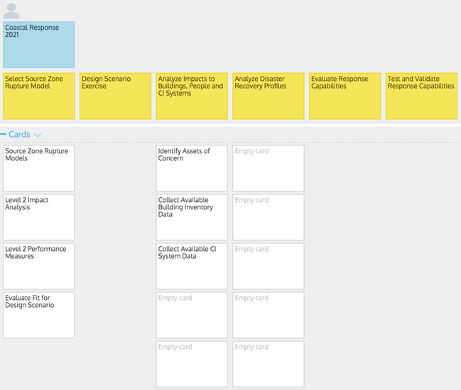

End User: Community Planner

Role/Responsibility: Land use planners have a primary role in researching and developing public policy strategies to manage the allocation and use of land in ways that reconcile individual and collective rights and that balance competing demands for economic vitality, social justice, quality of life, and environmental integrity. They are responsible for designing and facilitating the planning process in order to identify and develop policy recommendations that reflect the intent, values, and preferences of the community, and that are informed by relevant scientific and technical knowledge about human-natural systems and their interactions over time.

In the context of existing legislative frameworks such as land use bylaws and zoning ordinances (1–5 years), planners are often called on to assess whether proposed developments or land use activities are “safe for the use intended” and consistent with policies and regulations at multiple jurisdictional levels. Though responsible for informing day-to-day operational land use decisions, planners must also maintain a clear focus on the longer-term vision or intent of the community (5–30 years)— a vision that is developed through consultation, analysis, and the evaluation of policy alternatives. This involves a strategic assessment of current and anticipated future trends to direct the allocation of land in ways that will accommodate the varied needs and wants of a community while balancing thresholds for risk tolerance within the limits of available resources.

Primary needs and operational requirements for a land use planner in the context of disaster resilience are focused on issues of representation, judgments about scientific uncertainty, and perceptions about risk and political accountability. Planners need access to technical risk assessment information and guidelines that help facilitate risk-based planning at local or regional scales. They also need access to relevant domain experts to assist in the risk evaluation process and the interpretation of results. Finally, they need mechanisms to prioritize risk management options based on thresholds of risk tolerance that reflect community values and preferences and available knowledge about the risk environment.

Motivating Questions:

* What is the likelihood of experiencing a damaging earthquake in the planning area?
* What level of ground shaking can we anticipate?
* Are there other earthquake hazards of concern in this region (liquefaction, landslides, fire-following, etc.)?
* Where are the likely hotspots of building damage in the community and expected recovery times?
* What level of damage can we expect for critical assets of concern in the region?
* Who is most likely to be negatively affected by the impacts of a major earthquake?
* Who is most likely will be displaced from their homes and businesses following a major earthquake event?
* How long will it take to restore essential levels of functionality in areas hardest hit by a major earthquake?
* What are the likely financial consequences of a major earthquake?
* What are the most strategic opportunities for reducing underlying vulnerabilities through investments in seismic retrofit measures?
* What are the benefits and costs of proposed seismic mitigation measures?
* What incentives are needed to encourage investments in risk reduction measures?
* What are the potential co-benefits of investing in seismic mitigation?
* Are there other communities that share a similar risk profile who may have already developed relevant DRR policies?

Value Proposition: a collection of policy-based target indicators that can be used to assess baseline conditions of risk, and the potential for risk reduction through proactive investments in mitigation and/or adaptation measures

|  |  |
| --- | --- |
| C:\Users\slam\AppData\Local\Microsoft\Windows\INetCache\Content.MSO\EE72FAFB.tmp | Building Performance: Indicators that measure expected damage state and recovery time for buildings and critical facilities resulting from physical impacts of a disaster event. Supporting evidence includes neighborhood and site-level building inventories under development for settled areas in the region, and analytical fragility functions (GEM, UBC) that reflect the best available information about construction type and performance characteristics for standard North American building typologies  Damage Potential  Operational  Repairable  Failure  Collapse  Disaster Debris |
| C:\Users\slam\AppData\Local\Microsoft\Windows\INetCache\Content.MSO\301B49C1.tmp | B-1: Affected People: Indicators that measure the number and demographic characteristics of people likely to be injured and/or displaced as a result of physical impacts to buildings that are damaged in a disaster event. Included in the scope of assessment are characteristics of a place and its people that determine intrinsic capabilities to withstand and respond to chronic stresses and the acute shocks of a sudden disaster event. Supporting evidence includes 2106 Census data on population and demographic variables; empirical knowledge about the distribution of people at different times of the day based on occupancy and functional characteristics of individual building typologies.  B-2: People Injured  Minor Injuries  Critical Injuries  B-3: People Displaced  Immediate (<30 days)  Shelter Requirements  Short-Term (>30 days)  Sustained (> 90 days)  B-4: People Relocated  Temporary (>180 days)  Permanent (>360 days)  B-5: Livelihoods Disrupted  Business Interruption (>30 days)  Business Interruption (> 90 days) |
| C:\Users\slam\AppData\Local\Microsoft\Windows\INetCache\Content.MSO\AE06B795.tmp | C-1: Economic Security: Indicators that measure direct and indirect economic losses, and the potential for losses avoided through investments in mitigation/adaptation, and expected return on investment (RoI) for a given planning horizon.  Valuation of capital assets is based on industry standard replacement costs for structural and non-structural building components and contents.  C-2: Agricultural Loss & Loss Reduction Potential  C-3: Productive Asset Loss (Business Sector) & Loss Reduction Potential  C-4: Residential Asset Loss & Loss Reduction Potential  C-5: CI Asset Loss & Loss Reduction Potential  C-6: Cultural Heritage Asset Loss & Loss Reduction Potential |
| C:\Users\slam\AppData\Local\Microsoft\Windows\INetCache\Content.MSO\D81A236B.tmp | D-1: Critical Infrastructure: Indicators that measure direct and indirect impacts to critical infrastructure systems with a potential to cause disruption of basic services. This includes direct physical impacts and anticipate damage to individual facilities and assets; and the cascading effects of failures through the network of interconnected CI systems  D2: Health Sector  D3: Government Sector  D4: Transportation Sector  D5: Lifeline Services  Safety  Finance  Manufacturing |

Preferred Channel(s) of Communication:

1. Online maps and summary statistics (infoViz charts) for selected regions of interest.
2. Downloadable ‘Risk Profile ‘report for selected region(s) and indicators of interest.
3. Download risk assessment data for selected region(s) and indicators of interest.
4. Access to domain experts to assist with the interpretation of risk assessment outputs

User Story Map:

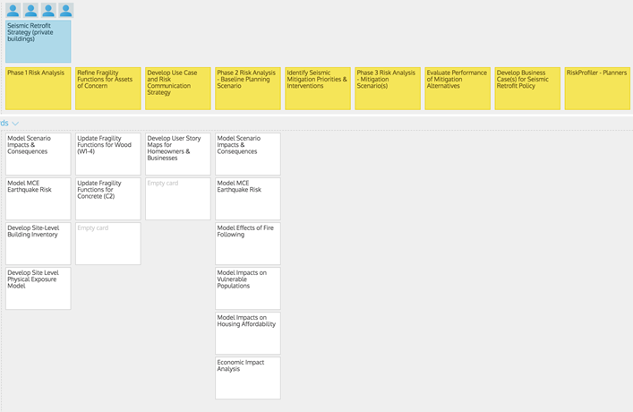

End User: Risk Analyst

Role/Responsibility: Domain experts are called upon to provide insights on the causes and driving forces of natural hazard processes, and to diagnose the likely impacts and consequences of these events on society and the environment. They can include individuals from public, private, and academic sectors with a theoretical background and expertise in the physical sciences, engineering, the social sciences, or humanities. Unlike planners and members of the general public, domain experts are focused primarily on the generation of knowledge for the purpose of refining or expanding an understanding of human-natural systems and how they work. They have a primary role in identifying existing and emerging societal risk, and in assessing the implications of these risks to inform planning and policy development (analysis and evaluation).

In the context of the physical sciences and engineering, time horizons of interest will vary depending on the nature of the hazard threat. They can range from near real-time monitoring of natural or anthropogenic processes (severe weather, floods, hurricanes, etc.) that have a potential to trigger hazard events over relatively short time intervals (0–50 years) to theoretical or computational modelling of larger-scale processes (earthquakes, landslides, global climate change, etc.) that have a potential to trigger hazard events over geologic time frames of decades and centuries (100–10,000 years).  In the context of the social sciences and humanities, the focus is on historical trends and existing conditions that may shed light on intrinsic patterns of vulnerability, and the adaptive capabilities of individuals to withstand, respond to and recover from disaster events.

As the creatores of new information and knowledge about the risk environment, domain experts are primarily concerned about issues of complexity and uncertainty. They require an internally consistent set of protocols to measure and describe system conditions and driving forces of risk in the environment, and a corresponding set of methods and tools that can be used to analyze hazard potential, the impacts and consequences of credible hazard events, and to evaluate both single and multi-hazard event risk scenarios over time horizons of interest to the planning process. In addition, they need methods and tools to assist in communicating the results of their assessments in ways that make evident scientific uncertainties and underlying assumptions about system behavior.

User Story Map:

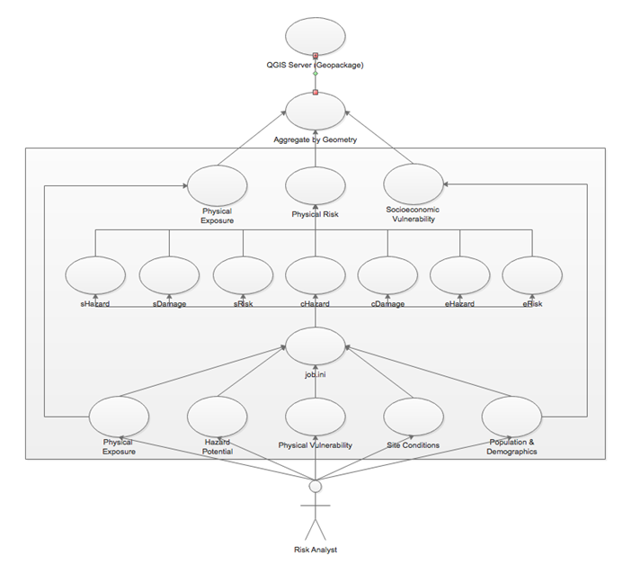

# Appendix B - Vocabularies and Ontologies

Definition of standards is a very important step in many applications (Figure 14), including the OpenDRR platform.

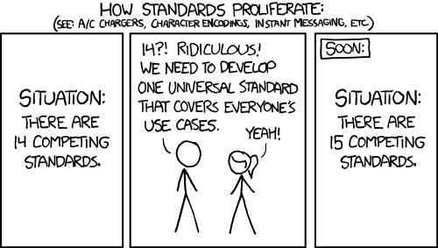

Figure 14. The importance of definition of standards. (<https://xkcd.com/927/>)

### B1 UNISDR - Sendai Framework for Disaster Risk Reduction

OpenDRR indicators connect to the Sendai Global targets (Figure 15)

Global target A: Substantially reduce global disaster mortality by 2030, aiming to lower average per 100,000 global mortality between 2020-2030 compared with 2005-2015.

* A-1 (compound) Number of deaths and missing persons attributed to disasters, per 100,000 population.
* A-2 Number of deaths attributed to disasters, per 100,000 population.
* A-3 Number of missing persons attributed to disasters, per 100,000 population.

Global target B: Substantially reduce the number of affected people globally by 2030, aiming to lower the average global figure per 100,000 between 2020-2030 compared with 2005-2015

* B-1 (compound) Number of directly affected people attributed to disasters, per 100,000 population.
* B-2 Number of injured or ill people attributed to disasters, per 100,000 population.
* B-3 Number of people whose damaged dwellings were attributed to disasters.
* B-4 Number of people whose destroyed dwellings were attributed to disasters
* B-5 Number of people whose livelihoods were disrupted or destroyed, attributed to disasters.

Global target C: Reduce direct disaster economic loss in relation to global gross domestic product (GDP) by 2030.

* C-1 (compound) Direct economic loss attributed to disasters in relation to global gross domestic product.
* C-2 Direct agricultural loss attributed to disasters.
* C-3 Direct economic loss to all other damaged or destroyed productive assets attributed to disasters.
* C-4 Direct economic loss in the housing sector attributed to disasters.
* C-5 Direct economic loss resulting from damaged or destroyed critical infrastructure attributed to disasters
* C-6 Direct economic loss to cultural heritage damaged or destroyed attributed to disasters

Global target D: Substantially reduce disaster damage to critical infrastructure and disruption of basic services, among them health and educational facilities, including through developing their resilience by 2030.

* D-1 Damage to critical infrastructure attributed to disasters.
* D-2 Number of destroyed or damaged health facilities attributed to disasters.
* D-3 Number of destroyed or damaged educational facilities attributed to disasters

Global target E: Substantially increase the number of countries with national and local disaster risk reduction strategies by 2020

* E-1 Number of countries that adopt and implement national disaster risk reduction strategies in line with the Sendai Framework for Disaster Risk Reduction 2015-2030.
* E-2 Percentage of local governments that adopt and implement local disaster risk reduction strategies in line with national strategies.

Global target F: Substantially enhance international cooperation to developing countries through adequate and sustainable support to complement their national actions for implementation of this framework by 2030

* F-1 Total official international support, (official development assistance (ODA) plus other official flows), for national disaster risk reduction actions
* F-2 Total official international support (ODA plus other official flows) for national disaster risk reduction actions provided by multilateral agencies.
* F-3 Total official international support (ODA plus other official flows) for national disaster risk reduction actions provided bilaterally
* F-4 Total official international support (ODA plus other official flows) for the transfer and exchange of disaster risk reduction- related technology
* F-5 Number of international, regional and bilateral programmes and initiatives for the transfer and exchange of science, technology and innovation in disaster risk reduction for developing countries
* F-6 Total official international support (ODA plus other official flows) for disaster risk reduction capacity-building
* F-7 Number of international, regional and bilateral programmes and initiatives for disaster risk reduction-related capacity- building in developing countries.
* F-8 Number of developing countries supported by international, regional and bilateral initiatives to strengthen their disaster risk reduction-related statistical capacity

Global target G: Substantially increase the availability of and access to multi-hazard early warning systems and disaster risk information and assessments to the people by 2030.

* G-1 (compound G2-G5) Number of countries that have multi-hazard early warning systems.
* G-2 Number of countries that have multi-hazard monitoring and forecasting systems.
* G-3 Number of people per 100,000 that are covered by early warning information through local governments or through national dissemination mechanisms.
* G-4 Percentage of local governments having a plan to act on early warnings.
* G-5 Number of countries that have accessible, understandable, usable and relevant disaster risk information and assessment available to the people at the national and local levels.
* G-6 Percentage of population exposed to or at risk from disasters protected through pre-emptive evacuation following early warning.

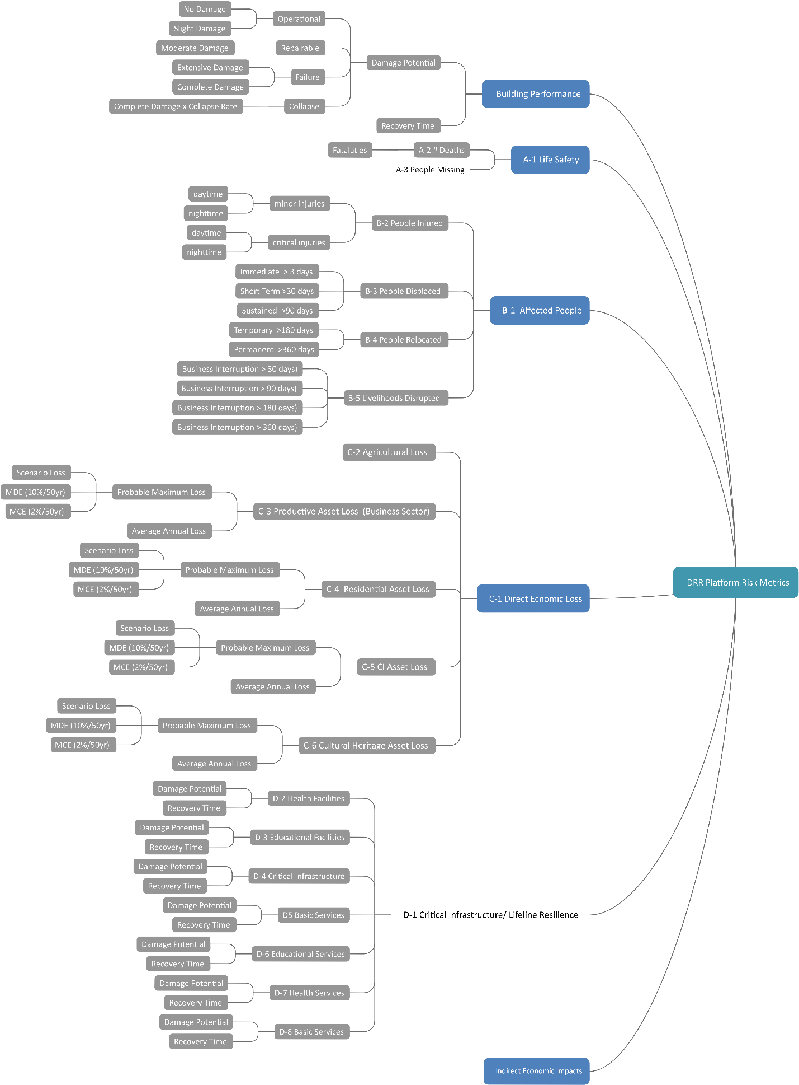

Figure 15 Metrics for Risk assessment. Boxes with letter-number prefixes are from the Sendai Framework. Other metrics are specific to the OpenDRR

### B2 INSPIRE - Infrastructure for Spatial Information in the European Community

INSPIRE Natural Risk Zone Application schema encompasses both hazard and risk terminology (Figure 16). The Hazard terminology appears to be insufficient to describe hazards in detail, for example there is the term ‘Landslide’ but it is not possible to describe the type of landslide (Figure 17). This is one of the many examples where INSPIRE need further implementation.

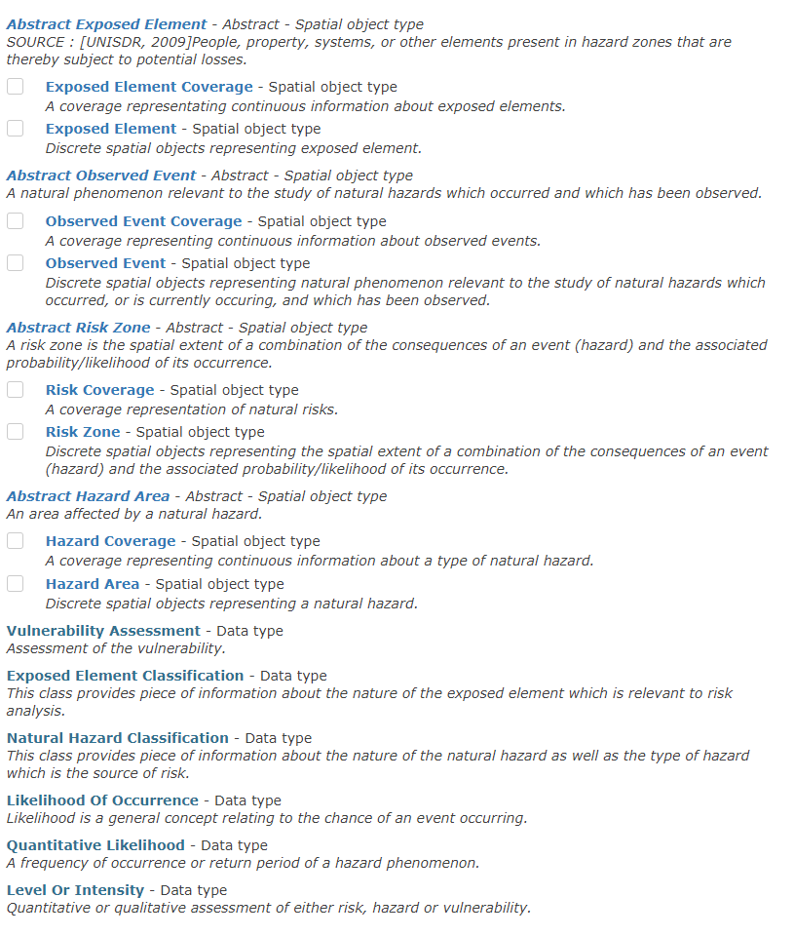

Figure 16 Natural Risk Zone Application schema http://inspire-regadmin.jrc.ec.europa.eu/dataspecification/ScopeObjectPreselection.action

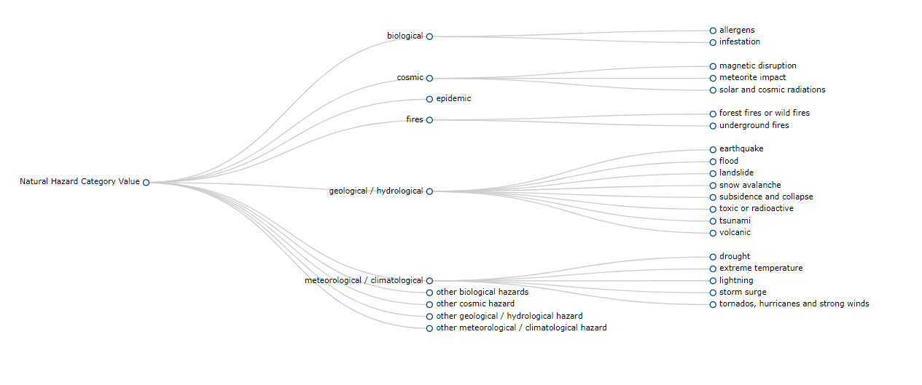

Figure 17 Radial graph view of Natural Hazard Category Value code list http://inspire-regadmin.jrc.ec.europa.eu/dataspecification/ScopeObjectDetail.action?objectDetailId=10621.

### B3 GEM – Global Earthquake Model

Earthquake Intensity measure Type

* PGA – Peak Ground Acceleration, measured in fractions of g
* PGV - Peak Ground Velocity, measured in cm/s
* PGD – Peak Ground Displacement, measured in cm
* Sa(T) - Spectral Acceleration for a given period T – indicated as Sa(T) - measured in fractions of g
* GMMT – Ground Motion Measurement Type
* IML – Intensity Measure Level

Social vulnerability factors (Figure 18)

* Number of loss-based damage states: (no damage, slight, moderate, extensive, complete)
* Number of functional-based limit states: (no damage, trigger inspection, loss function, not occupiable, irreparable, collapse)
* Transfer Probabilities: The element (i, j) of the matrix is the probability that the recovery-based limit state j occurs, given the loss-based damage state i
* Assessment times: Time to conduct engineering assessment
* Inspection times: Time to complete inspections
* Mobilization times: Time to mobilize for construction
* Recovery times: Period between the occurrence of the earthquake and the restoration of full functionality
* Repair times: Time to replace elements in buildings or to reconstruct buildings
* Repair times dispersion: Level of uncertainty associated with the repair times
* Lead times dispersion: Level of uncertainty associated with the lead times

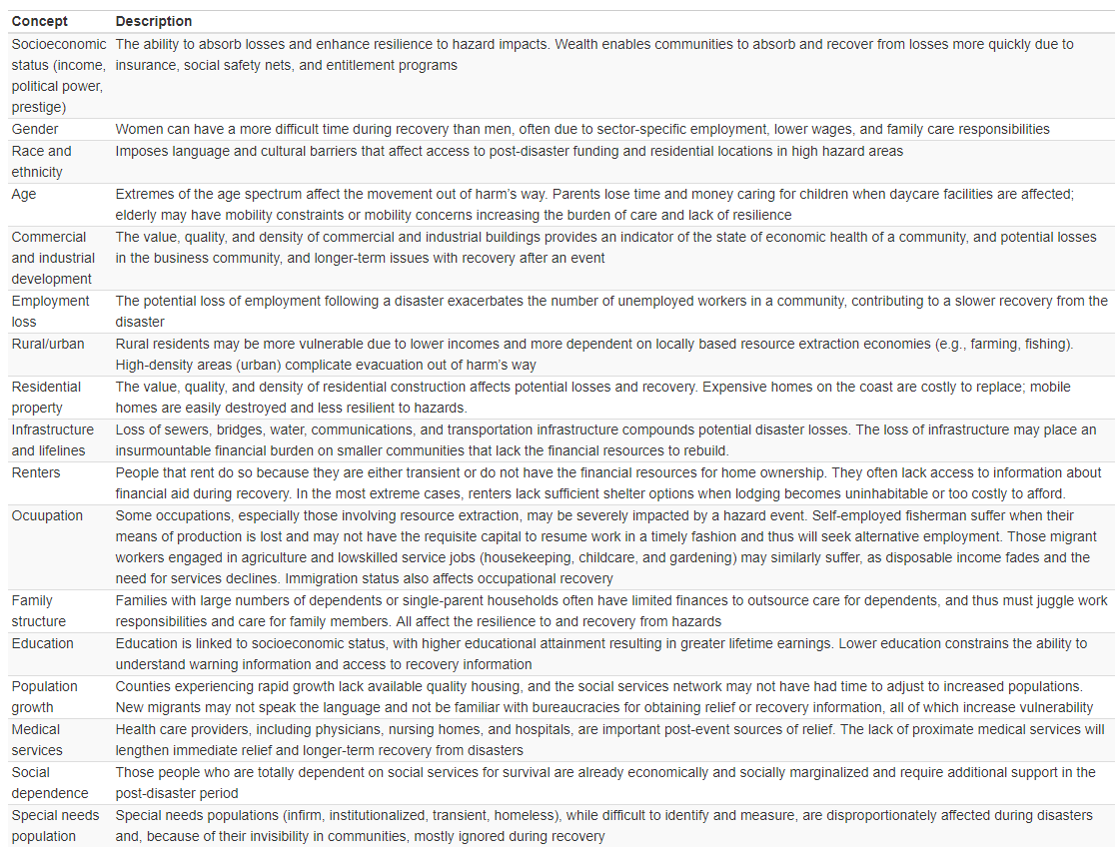

Figure 18 Factors of social vulnerability after (Cutter, Boruff, & Shirley, 2003)

Building Taxonomy

13 attributes of GEM Building Taxonomy:

1. Direction – the orientation of building(s) with different lateral load-resisting systems in two principal horizontal directions of the building plan which are perpendicular to one another
2. Material of the lateral load-resisting system - e.g. "masonry" or "wood"
3. Lateral load-resisting system - the structural system that provides resistance against horizontal earthquake forces through vertical and horizontal components, e.g. "wall", "moment frame", etc.
4. Height - building height above ground in terms of the number of storeys (e.g. a building is 3-storey high); this attribute also includes information on the number of basements (if present) and the ground slope
5. Date of construction or retrofit - the year in which the building construction or retrofit was completed
6. Occupancy - the type of activity (function) that the building is used for
7. Building position within a block - the position of a building within a block of buildings (e.g. a "detached building" is not attached to any other building)
8. Shape of the building plan - e.g. L-shape, rectangular shape, etc.
9. Structural irregularity - features of a building's structural arrangement that are irregular; such as one story is significantly higher than other stories, or the building has an irregular shape. Also the change of the structural system or materials that produce known vulnerability during an earthquake fall into this category. Re-entrant corner and soft story are examples.
10. Exterior walls - material of exterior walls (building enclosure), e.g. "masonry", "glass", etc.
11. Roof - this attribute describes the roof shape, material of the roof covering, structural system supporting the roof covering, and the roof-wall connection. For example, the roof shape may be "pitched with gable ends", roof covering could be "tile", and the roof system may be "wooden roof structure with light infill or covering".
12. Floor - describes the floor material, floor system type, and floor-wall connection. For example, the floor material may be "concrete", and the floor system may be "cast in-place beamless reinforced concrete slab".
13. Foundation - that part of the construction where the base of the building meets the ground. The foundation transmits loads from the building to the underlying soil. For example, a shallow foundation supports walls and columns in a building for hard soil conditions, and a deep foundation needs to be provided for buildings located in soft soil areas.

### B4 MOVER - Multi-Hazard Open Vulnerability Platform for Evaluating Risk

MOVER modules from Epicentre, (2018)

Vulnerability characteristics (V_Ch) are descriptors of the main factors contributing to the (social or physical) vulnerability of the asset to a hazard. An example of a V_Ch is level of literacy, which contributes to the social vulnerability of populations.

Vulnerability categories (V_Cat) are a grouping of vulnerability characteristics that fall under the same theme. For example, the V_Ch of ‘Access to Education’ and ‘Education Attainment’ are grouped within a V_Cat of “Knowledge and Education”.

A Vulnerability Indicator (VI)

is a direct measure or proxy for measuring a vulnerability characteristic (V_Ch). It is a quantitative measure of a single phenomenon. An example VI is the percentage of the population with a primary school level education, when this is used as a proxy for literacy (V_Ch) as part of an evaluation of the V_Cat of “Education”. VIs are most commonly used to indicate factors of social vulnerability, but in physical vulnerability are the equivalent of direct quantitative measures or proxies for vulnerability characteristics of the exposure.

A Vulnerability Index (VIx)

is a quantitative representation of multiple phenomena, i.e., of multiple V_Cat. It is a vulnerability model and is formed through a mathematical combination of several Vulnerability Indicators. An example VIx from the social vulnerability literature is the Human Development Index. In the physical vulnerability sphere VIx usually result from rapid visual surveys of buildings. Examples include the Building

A Vulnerability Function (VF)

is defined as a relationship between a parameter of loss (e.g. fatalities) and an intensity measure (IM). Such functions can be represented in the form of continuous or discrete relationships. VFs can be derived “directly” from regression on historical loss data (empirical), and through the elicitation of expert opinion (heuristic). VFs can also be derived “indirectly” from the combination of a Fragility Function and a Damage- to-Loss model.

A Fragility Function (FF)

describes the propensity of physical assets (e.g. buildings) to sustain damage under hazardous events. Formally, they express the probability of a damage state (DS) being reached or exceeded given a range of hazard intensity measure levels. FFs can be developed empirically, heuristically, but also analytically (i.e. where a numerical/computational model simulates the response of a structure under increasing hazard intensities).

A Damage-to-Loss model (DtL)

relates values of loss to the damage states expressed in a Fragility Function. For buildings and most infrastructure DtL models commonly take the form of repair to replacement cost ratios for the examined building class. In the case of pipelines and cables Repair Rates (RR), which describe the average number of repairs per unit length, are more common. In the case of casualties, Damage-to-Loss relationships often take the form of Lethality Ratios (LR), as the ratio of the number of people killed to the number of occupants present in a collapsed building

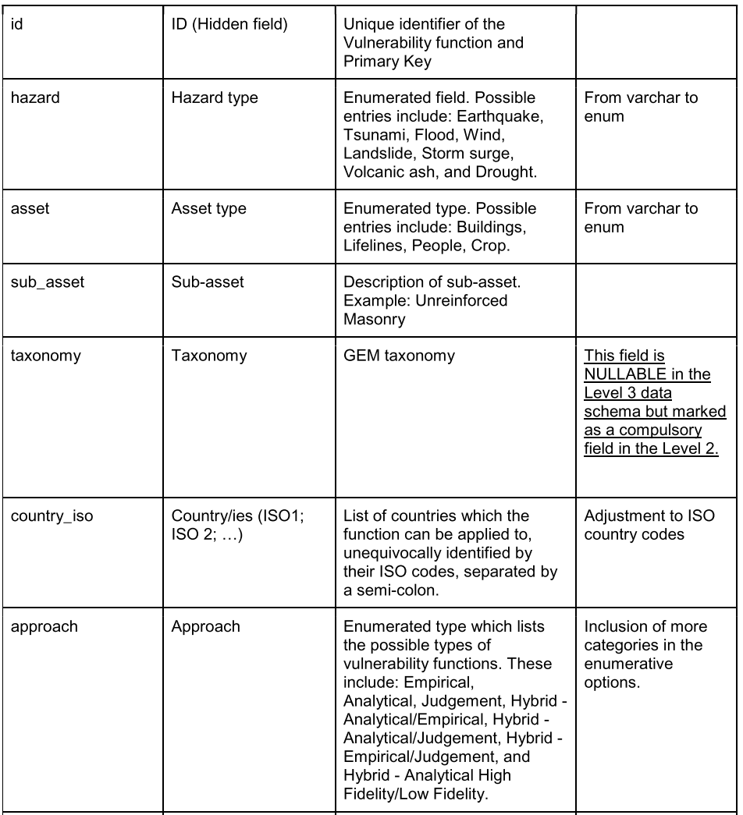

Figure 19 extract of MOVER vulnerability schema

# Appendix C – Feature Comparison Matrix

Comparisons between existing spatial data infrastructures and web mapping applications are illustrated in subsequent feature matrices to identify desirable functionality for the OpenDRR platform.

|  |  |  |  |  |  |  |
| --- | --- | --- | --- | --- | --- | --- |
| Features | FGP | OpenQuake | Arctic SDI | Risk Data Hub | One Geology | GIN |
| Framework |  |  |  |  |  |  |
| Centralized Catalog | x |  | x | x | x |  |
| Geospatial Data Visualization App | x | x | x |  | x | x |
| Service Oriented Architecture | x |  | x |  | x |  |
| Metadata Management | x |  |  |  |  |  |
| Distributed Data Sources | x |  | x |  | x | x |
| Hosted Data Sources |  | x |  | x |  |  |
| Interchange Formats |  |  |  |  |  |  |
| CSV |  | x |  |  |  |  |
| Custom XML schema | x | x | x |  | x | x |
| JSON, GeoJSON | x |  |  |  |  |  |
| KML | x | x |  |  |  |  |
| RDF |  |  |  |  |  | x |
| Standard Image Formats (.tiff, .png, .jpeg) |  |  |  |  | x |  |
| external web service support (Open Street Map, Bing, Google, etc) | x |  |  |  |  |  |
| Supported Map Services |  |  |  |  |  |  |
| OGC WFS | x |  | x |  | x | x |
| OGC WMS | x | x | x | x | x | x |
| OGC WCS | x |  |  |  |  | x |
| OGC CSW (Catalogue Service for the Web) | x | x | x |  |  | x |
| OGC WMTS |  | x | x |  |  |  |
| OGC WMS-T (time series) |  |  | x |  |  |  |
| KML | x | x |  |  |  |  |
| Raster REST (ESRI) |  |  | x |  |  |  |
| Standards |  |  |  |  |  |  |
| GeoSciML |  |  |  |  | x |  |
| GWML |  |  |  |  |  | x |
| Sendai Framework |  | x |  | x |  |  |
| ISO | x |  | x |  | x |  |
| INSPIRE |  |  | x | x |  |  |
| Catalog Capabilities |  |  |  |  |  |  |
| Search & discover | x |  | x | x |  |  |
| Update Data | x |  |  | x |  |  |
| Download Data | x |  |  | x |  |  |
| Web Map Capabilities |  |  |  |  |  |  |
| Search and add layers from catalog |  |  | x | x |  |  |
| Upload data |  |  |  | x |  |  |
| See metadata |  |  | x | x | x |  |
| Location Search |  |  | x | x |  |  |
| Filter features |  |  |  | x |  |  |
| Combine layers |  |  |  | x |  |  |
| Generate Reports |  |  |  | x |  |  |
| Software - Database |  |  |  |  |  |  |
| ArcSDE | x |  |  |  |  |  |
| Oracle | x |  |  |  |  |  |
| PostGIS | x |  |  | x | x |  |
| PostgreSQL | x |  |  | x |  |  |
|  |  |  |  |  |  |  |
| Software - Catalogue |  |  |  |  |  |  |
| GeoNetwork | x |  |  |  |  |  |
| GeoPortal | x |  |  |  |  |  |
| EODMS (NRCAN) | x |  |  |  |  |  |
| GeoGratis API (NRCAN) | x |  |  |  |  |  |
| Software - Web Platform |  |  |  |  |  |  |
| ArcGIS Online | x |  |  |  |  |  |
| GeoNode |  |  |  | x |  |  |
| MapServer (NRCAN) | x |  |  |  |  |  |
| Minnesota MapServer |  |  |  |  | x |  |
| Software - Web Server |  |  |  |  |  |  |
| ArcGIS Server | x |  |  |  | x |  |
| GeoServer |  |  |  | x | x |  |
| QGIS Server |  | x |  |  |  |  |

# References

Abbas, S., and Ojo, A. 2013. Towards a Linked Geospatial Data Infrastructure. Technology-Enabled Innovation for Democracy, Government and Governance: Proceedings of the Joint International Conference on Electronic Government and the Information Systems Perspective, and Electronic Democracy (EGOVIS/EDEM 2013), **8061**: 196–210. Available from http://link.springer.com/chapter/10.1007/978-3-642-40160-2_16.

Antofie, T.E., Doherty, B., and Marin-Ferrer, M. 2018. Mapping of risk web-platforms and risk data: collection of good practices. Improving the access and share of curated EU-wide risk data for fostering DRM. doi:10.2760/93157.

Arctic SDI. 2015. Arctic Spatial Data Infrastructure Framework Document.

Barker, T. 2007. Climate Change 2007 : An Assessment of the Intergovernmental Panel on Climate Change. Change, **446**: 12–17. IPCC. doi:10.1256/004316502320517344.

Epicentre. 2018. MOVER – Level 3 Data schema for Physical and Social Vulnerability Indicators , Indices , and Functions. London.

FEMA. 2009. Comprehensive Data Management System CDMS Version 2.5 Data Dictionary. Washington. D.C.

Guidoin, S., Marczak, P., Pane, J., and McKinney, J. 2014. Identifying recommended standards and best practices for open data. OpenNorth, http://geothink.ca/wp-content/uploads/2016/02/Identifying-Recommended-Standards-Open-Data-Open-North.pdf

Harvey, F., Jones, J., Scheider, S., Iwaniak, A., Kaczmarek, I., Lukowicz, J., and Strzelecki, M. 2014. Little Steps Towards Big Goals. Using Linked Data to Develop Next Generation Spatial Data Infrastructures (aka SDI 3.0). *In* Agile’2014. pp. 3–6.

Harvey, M., Eltinay, N., Barnes, S., Guerriero, R., and Caffa, M. 2018. Infrastructure for City Resilience. Available from http://creativecommons.org/licenses/by/3.0/igo/.

JRC EU expert working group on disaster damage and loss data. 2015. Guidance for Recording and Sharing Disaster Damage and Loss Data. JRC Science and Policy Reports,: 28. doi:10.2788/186107.

Kelman, I. 2018. Lost for Words Amongst Disaster Risk Science Vocabulary? International Journal of Disaster Risk Science, **9**: 281–291. Beijing Normal University Press. doi:10.1007/s13753-018-0188-3.

Natural Resources Canada. 2015. Integrated Enterprise Architecture - Federal Geospatial Platform.

Do Ó, F.A., Poljanšek, K., and Vallés, A.C. 2018. Disaster damage and loss data for policy. Publication Office of the European Union. doi:10.2760/840421.

Poljanšek, K., De Groeve, T., Marín Ferrer, M., and Clark, I. 2017. Science for disaster risk management 2017: knowing better and losing less. EUR 28034 EN, Publications Office of the European Union, Luxembourg. doi:10.2788/688605.

Schade, S., and Lutz, M. 2010. Opportunities and challenges for using linked data in inspire. *In* CEUR Workshop Proceedings. pp. 3–7.

Silva, V., Yepes-Estrada, C., Dabbeek, J., and Martins, L. 2017. GED4ALL - Global Exposure Database for Multi-Hazard Risk Analysis - Inception Report. Pavia, Italy.

UNISDR. 2015. Sendai Framework for Disaster Risk Reduction 2015 - 2030. doi:A/CONF.224/CRP.1.

Vilches-Blázquez, L.M., Villazón-Terrazas, B., De Leon, A., Priyatna, F., and Corcho, O. 2010. An approach to publish spatial data on the web: The geolinked data case. CEUR Workshop Proceedings, **691**.

World Bank. 2014. Open Data for Resilience Initiative Field Guide. Washington, DC. Available from https://www.gfdrr.org/opendri.

World Economic Forum. 2019. The Global Risks Report 2019 13th Edition.

Xu, W., and Zlatanova, S. 2007. Ontologies for Disaster Management Response. *In* Geomatics Solutions for Disaster Management. Springer Berlin Heidelberg, Berlin, Heidelberg. pp. 185–200. doi:10.1007/978-3-540-72108-6_13.

# Glossary

|  |  |
| --- | --- |
| Abbreviation | Description |
| FGP | Federal Geospatial Platform |
| OpenDRR | Open Disaster Risk Reduction |
| NRCan | Natural Resources Canada |
| SDI | Spatial Data Infrastructure |
| GIS | Geographic Information System |

1. Section 2.2 Business Case is reproduced from Services Agreement between Sage On Earth Consulting Ltd. and Minerva Intelligence Inc. (Sage On Earth Consulting Ltd., 2019)
2. CityGML Initiative <http://www.citygml.org/>
3. OpenQuake Taxonomy <https://taxonomy.openquake.org/>
4. EERI World Housing Encyclopedia <http://db.world-housing.net/>
5. Prompt Assessment of Global Earthquakes for Response (PAGER) <https://earthquake.usgs.gov/data/pager/>
6. Hazus <https://www.fema.gov/hazus>
7. TaxtWeb – GEM Building Taxonomy Editor <https://platform.openquake.org/taxtweb/>
8. Global Facility for Disaster Reduction and Recovery (GFDRR) <https://www.gfdrr.org/en/who-we-are>
9. Multi-Hazard Open Vulnerability Platform for Evaluating Risk (MOVER) <https://www.preventionweb.net/publications/view/61104>
10. CityGML Codelist for Material of Roof <http://hub.geosmartcity.eu/registry/codelist/MaterialOfRoofValue/>
11. OpenQuake Engine GitHub Project <https://github.com/gem/oq-engine/blob/master/doc/web-api.md>